Testing document for MS Decom activities

Project: Z_FD45_QSPL_GR

System : xFE

CD: 151938.

Transport request: DFEK962733

—---------------------------------------------------------------------------------------------------------------------------------

1. LQA Dashboard report exporting into my Drive.

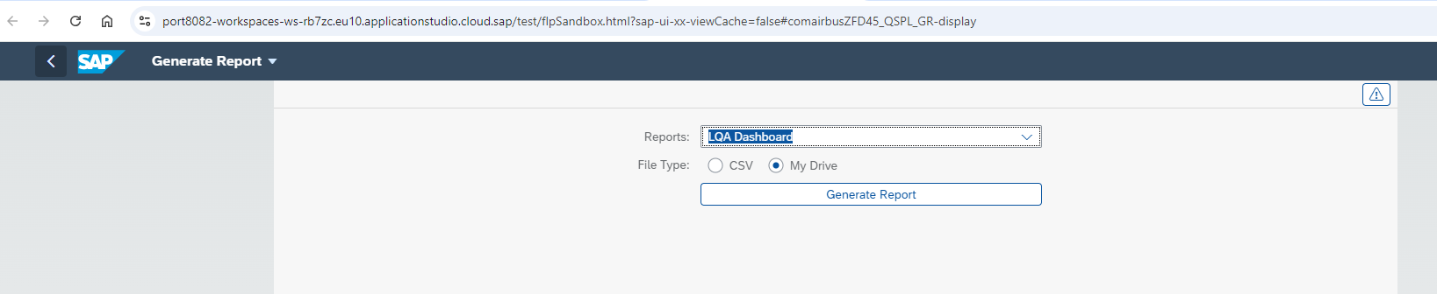

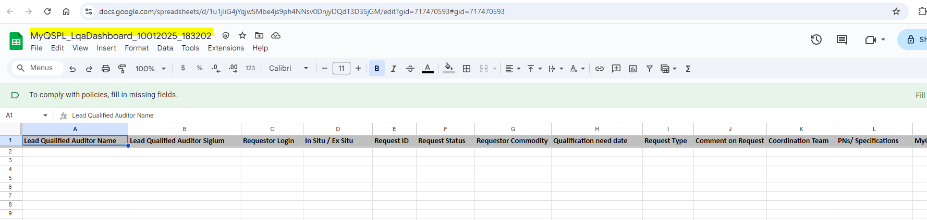

1. External Report In Situ

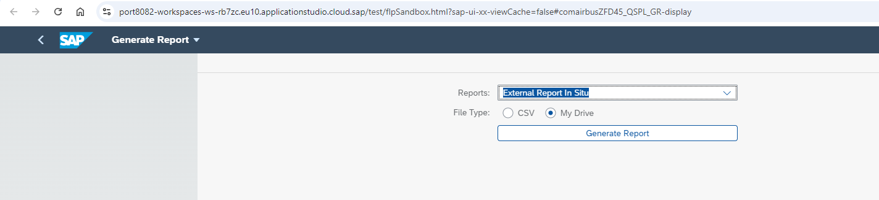

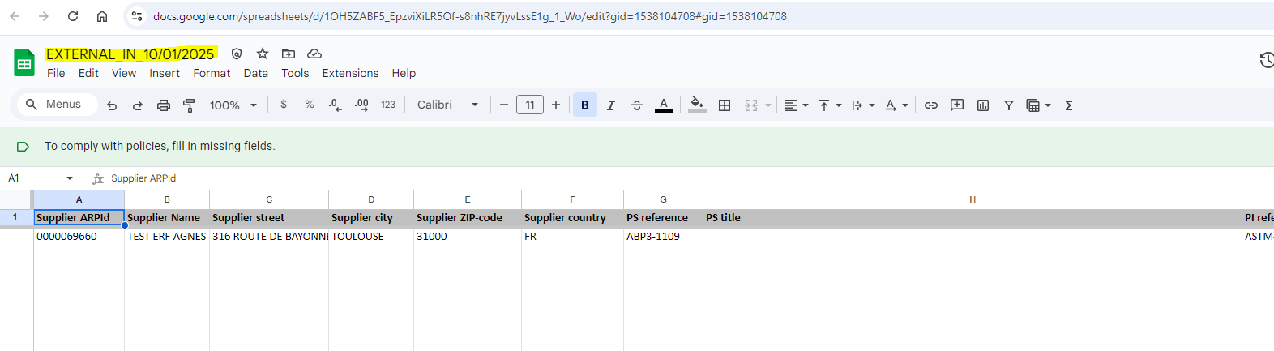

1. External Report Ex Situ:

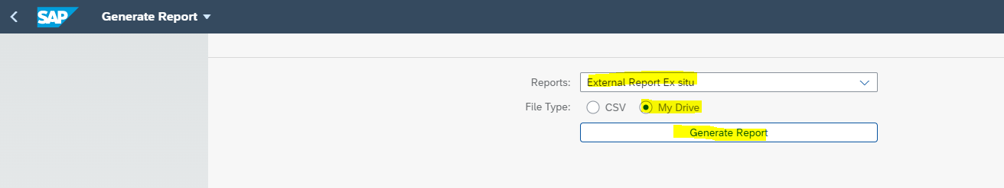

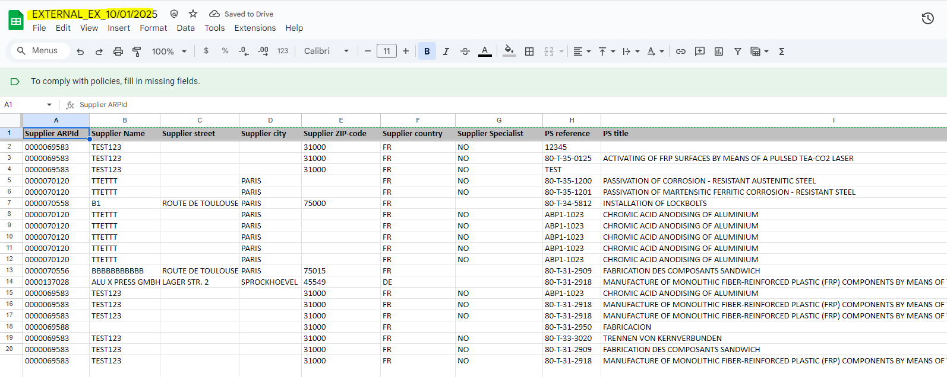

1. Internal Report In Situ / Ex Situ:

